/*1. Write a query to get Product name and quantity/unit*/

SELECT ProductName, QuantityPerUnit

FROM Products;

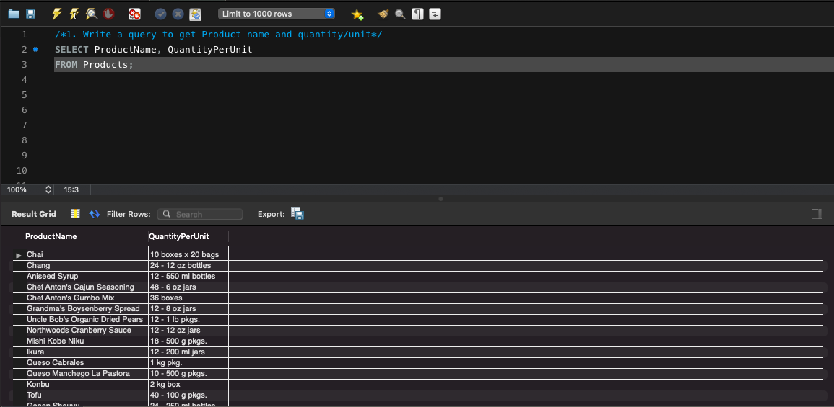

/*2. Write a query to get current Product list (Product ID and name)*/

SELECT ProductID, ProductName

FROM Products

WHERE Discontinued = "False"

ORDER BY ProductName;

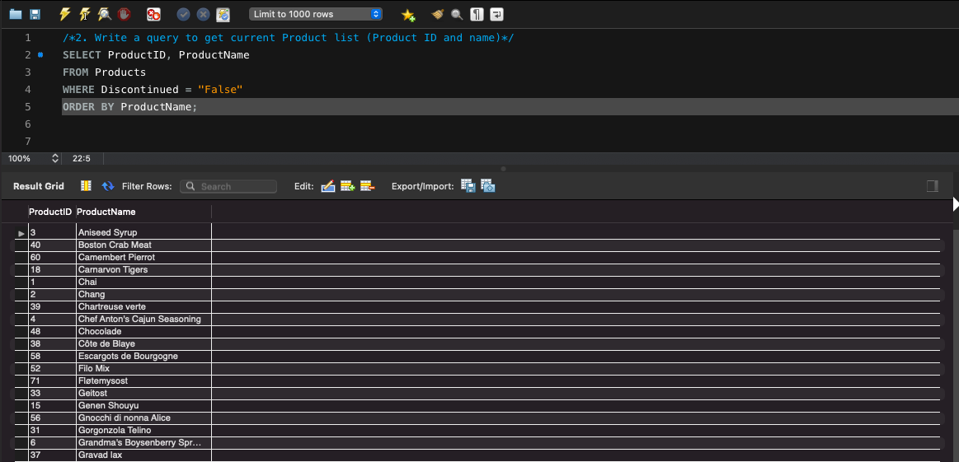

/*3. Write a query to get discontinued Product list (Product ID and name)*/

SELECT ProductID, ProductName

FROM Products

WHERE Discontinued = 1

ORDER BY ProductName;

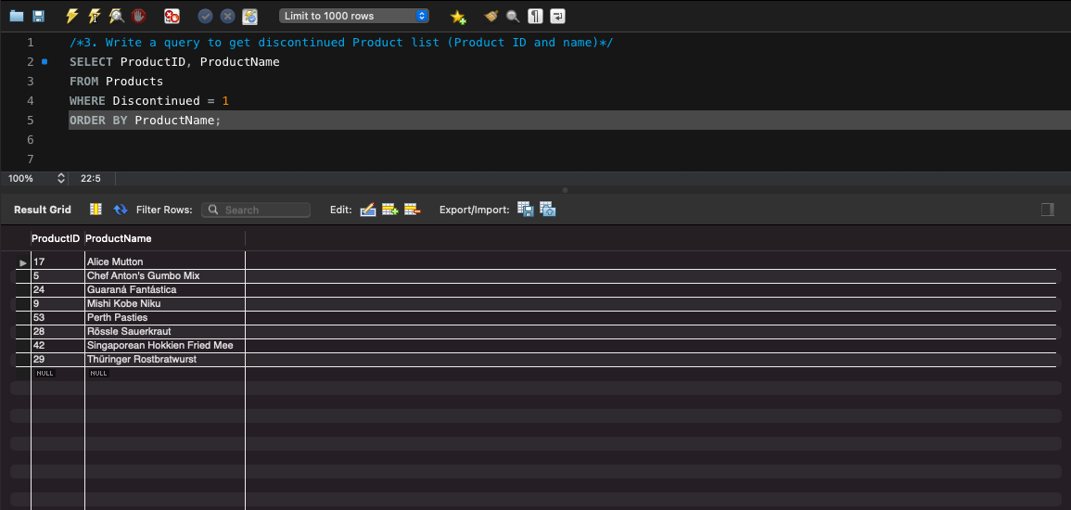

/*4. Write a query to get most expense and least expensive Product list (name and unit price)*/

SELECT ProductName, UnitPrice

FROM Products

ORDER BY UnitPrice DESC;

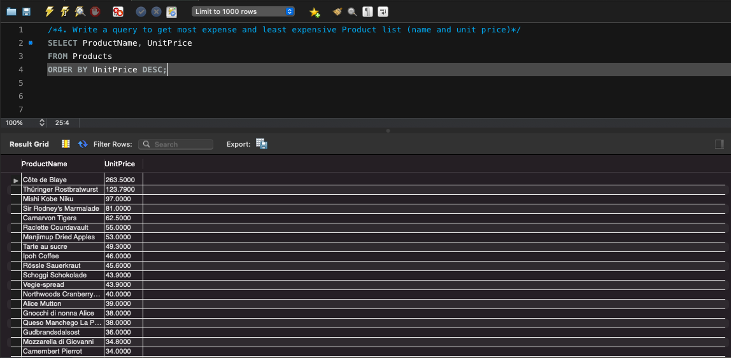

/*5. Write a query to get Product list (id, name, unit price) where current products cost less than $20*/

SELECT ProductID, ProductName, UnitPrice

FROM Products

WHERE (((UnitPrice)<20) AND ((Discontinued)=False))

ORDER BY UnitPrice DESC;

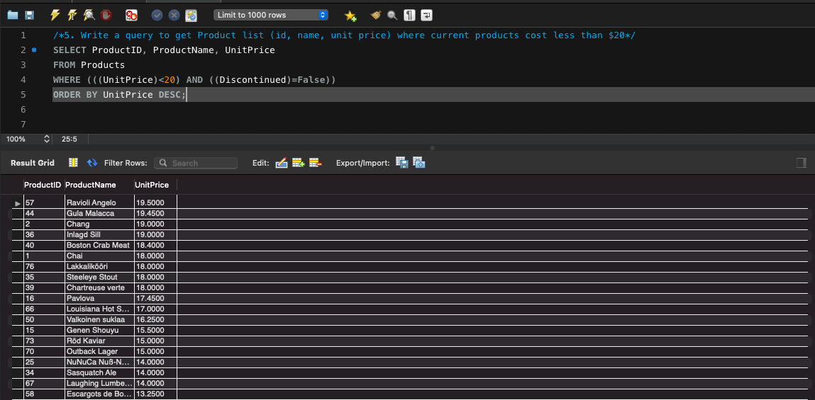

/*6. Write a query to get Product list (id, name, unit price) where products cost between $15 and $25*/

SELECT ProductName, UnitPrice

FROM Products

WHERE (((UnitPrice)>=15 And (UnitPrice)<=25)

AND ((Products.Discontinued)=False))

ORDER BY Products.UnitPrice DESC;

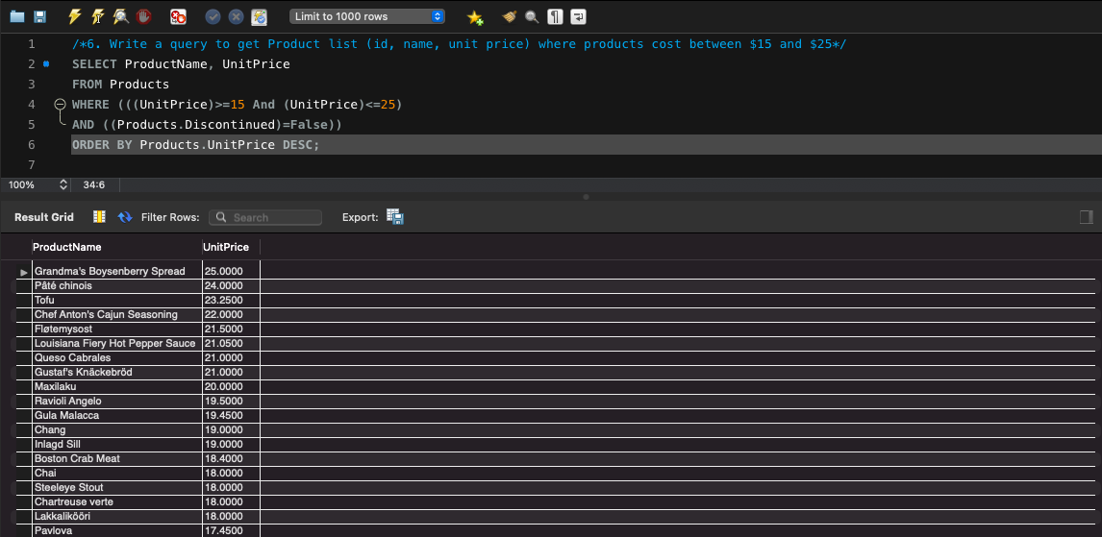

/*7. Write a query to get Product list (name, unit price) of above average price*/

SELECT DISTINCT ProductName, UnitPrice

FROM Products

WHERE UnitPrice > (SELECT avg(UnitPrice) FROM Products)

ORDER BY UnitPrice;

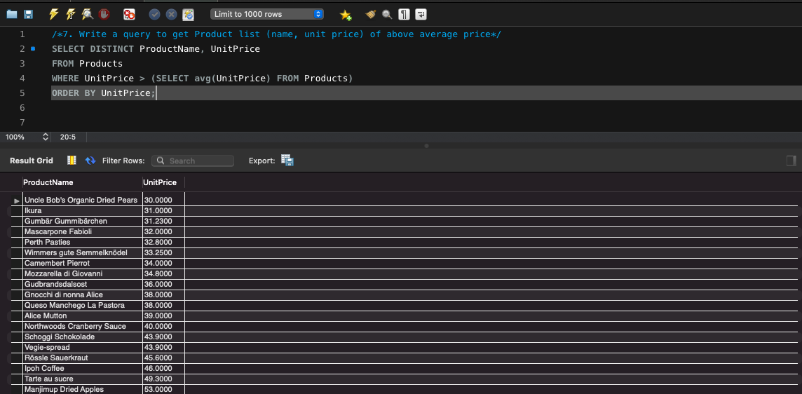

/*8. Write a query to get Product list (name, unit price) of ten most expensive products*/

SELECT DISTINCT ProductName as Ten_Most_Expensive_Products, UnitPrice

FROM Products AS a

WHERE 10 >= (SELECT COUNT(DISTINCT UnitPrice)

FROM Products AS b

WHERE b.UnitPrice >= a.UnitPrice)

ORDER BY UnitPrice desc;

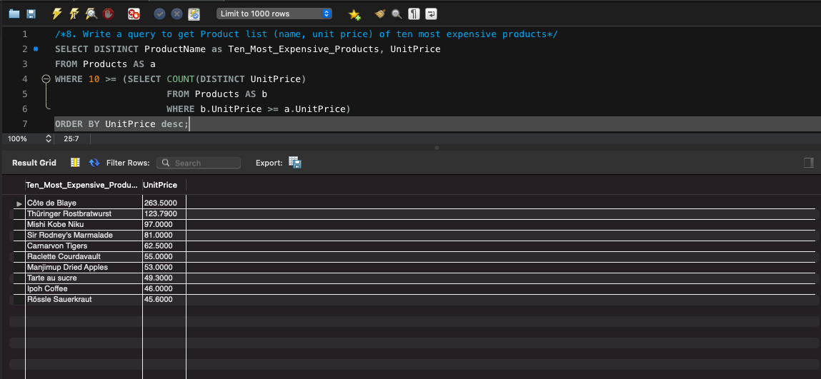

/*9. Write a query to count current and discontinued products*/

SELECT Count(ProductName)

FROM Products

GROUP BY Discontinued;

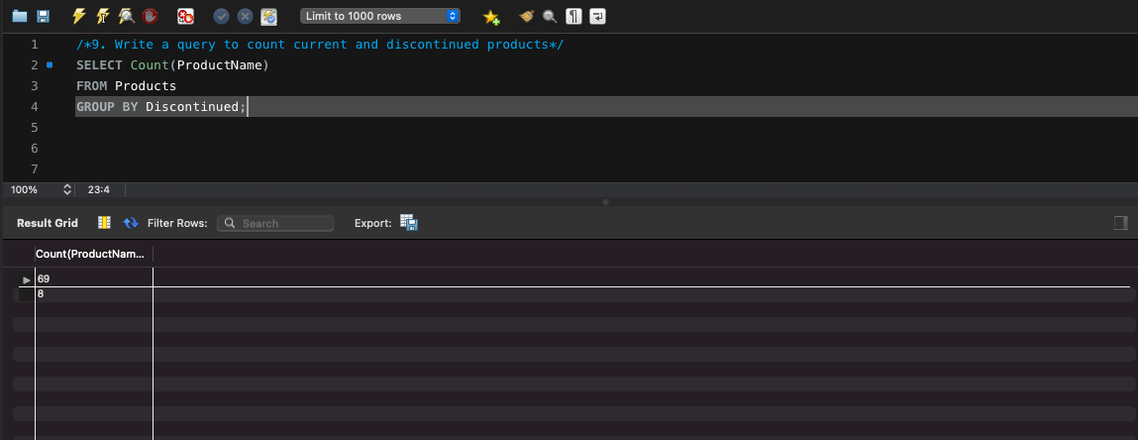

/*10. Write a query to get Product list (name, units on order , units in stock) of stock is less than the quantity

on order*/

SELECT ProductName, UnitsOnOrder , UnitsInStock

FROM Products

WHERE (((Discontinued)=False) AND ((UnitsInStock)<UnitsOnOrder));

